EXPERIMENT-9

**Creating Multiple EC2 Instances with for_each in Terraform**

**1. Create a Terraform Directory:**

**mkdir terraform-multiple-ec2 cd terraform-multiple-ec2**

* Create Terraform Configuration Files:
* Create a file named main.tf:

**# main.tf**

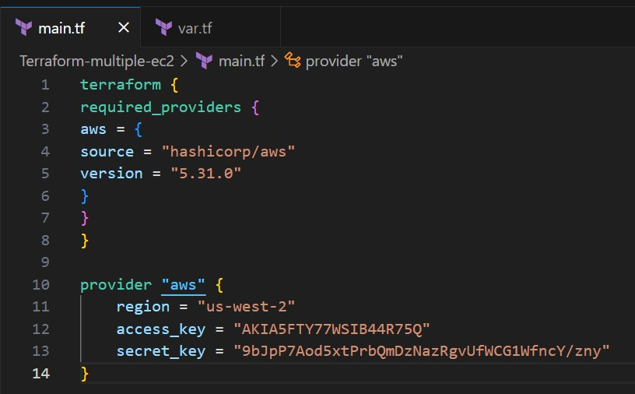

**#var.tf**

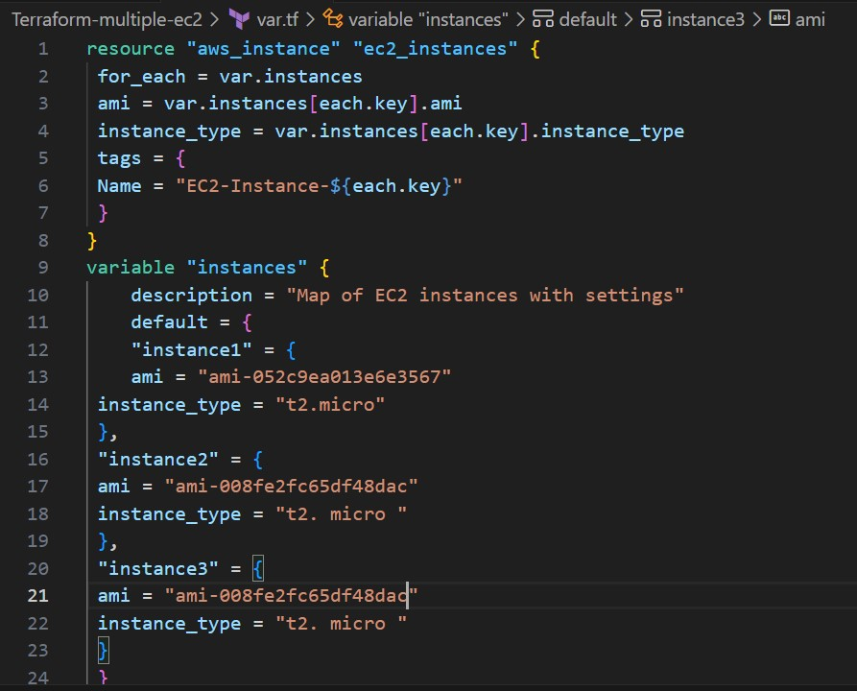

**2.Initialize and Apply:**

* Run the following Terraform commands to initialize and apply the configuration:

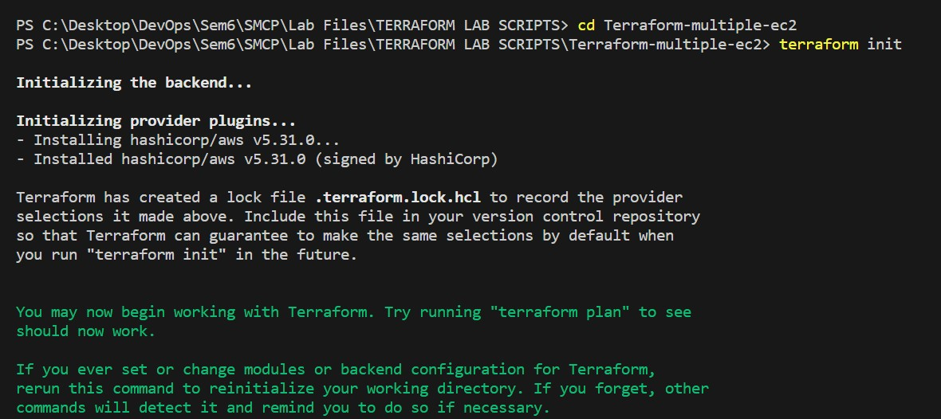

**terraform init terraform plan**

